CitiBike Analysis

## Phenomena #1:

The total trip miles have increased month over month and year over year while the number of bikes have decreased by over 100.

Analysis:

The decrease in bikes could be the result of multiple things; theft, damage, sale, etc. However, it is encouraging that CitiBike has still seen increased usage while bikes have decreased.

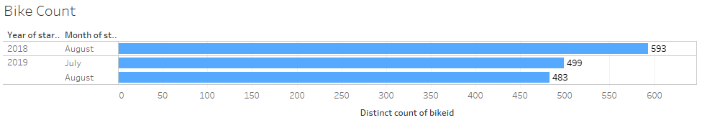

The full analysis on this can be seen on the Trip Comparison dashboard. My suggestion to CitiBike would be to look into a scheduling function that would allow users to reserve bikes for time slots. Using the scheduling piece, CitiBike could better understand the number of bikes needed to meet demand. Are the current number of bikes too high or too low? Further analysis is needed in these areas:

* Total use time of each bike ID
* How often are people waiting for bikes on a regular basis

## Phenomena #2:

The core user falls into the millennial generation, however there is a spike of users that were born in the 1970’s. Those users from the 1970’s are showing higher average trip time per ride then the millennial group.

Analysis:

Data suggest that a marketing push towards users born in the 1970’s could result in additional sales of single ride and subscriptions.

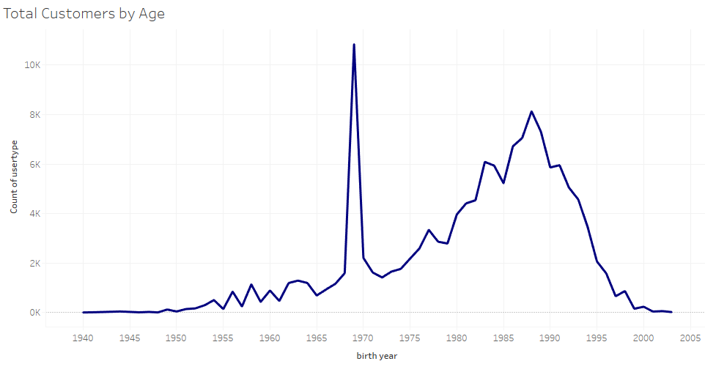

The full analysis is available on the Customer Data and Customer Breakdown dashboards. My suggestion to CitiBike would be to look into advertising that is specific to the older generations. Further analysis is needed in these areas:

* How are people learning about CitiBike
* What is the most common use of the bikes [IE – exercise, transportation, etc]
* How is the marketing department currently reaching users

## Phenomena #3:

Single use customers are targeting different starting stations then subscription customers

Analysis:

By breaking down popular start stations by user type, the top station remains the Grove Street PATH, but for strictly single use customers, the breakdown of start stations shows a tie with Columbus Dr at Exchange Pl. This suggests that the users that are only purchasing single use passes may be using the bikes for more variety of reasons like transportation, while subscribers are using the bikes for exercise.

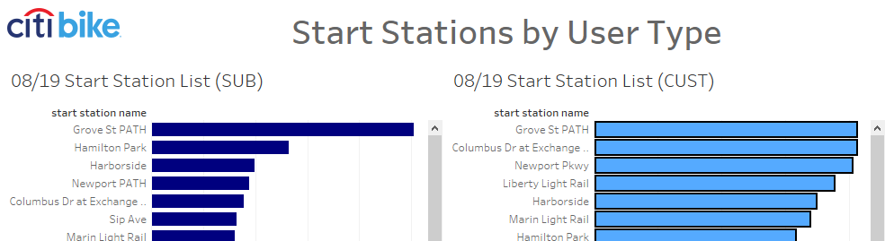

The full analysis is available on the Start Stations Dashboard. My suggestion to CitiBike would be to look at increasing the use of bikes for transportation from bus/train stops to user end points. Further analysis is needed in these areas:

* How can CitiBike identify how users are utilizing bikes
* Is there a way to work with local companies to give employees perks for utilizing bikes as part of their commute method